[**Michael Clemens**](https://clemens.name/)

* [**Blog**](https://clemens.name/blog/)
* [**Bookmarks**](https://clemens.name/bookmarks/)
* [**Projects**](https://clemens.name/projects/)
* [**DL6MHC**](https://clemens.name/dl6mhc/)
* [**About**](https://clemens.name/about/)

**Xiegu G90 Mods**

**Table of Contents**

1. [Mods](https://clemens.name/g90-mods/#mods)
   1. [Power Cable](https://clemens.name/g90-mods/#power-cable)
   2. [Microphone Mod](https://clemens.name/g90-mods/#microphone-mod)
   3. [Ferrite Beads](https://clemens.name/g90-mods/#ferrite-beads)
   4. [VFO Knob](https://clemens.name/g90-mods/#vfo-knob)
   5. [Head Unit Stand](https://clemens.name/g90-mods/#head-unit-stand)
2. [Useful other Information](https://clemens.name/g90-mods/#useful-other-information)

**Mods**

The following is a compilation of some recommended mods for the Xiegu G90. None of these mods are my idea, I learned about them from the Xiegu G90 group.io group (see below).

**Power Cable**

The original power cable is too thin and should be replaced with silicone 14AWG cables plus some ferrite beads. Don't forget to integrate a 5Ah fuse into the cable.

Mine looks like this now:

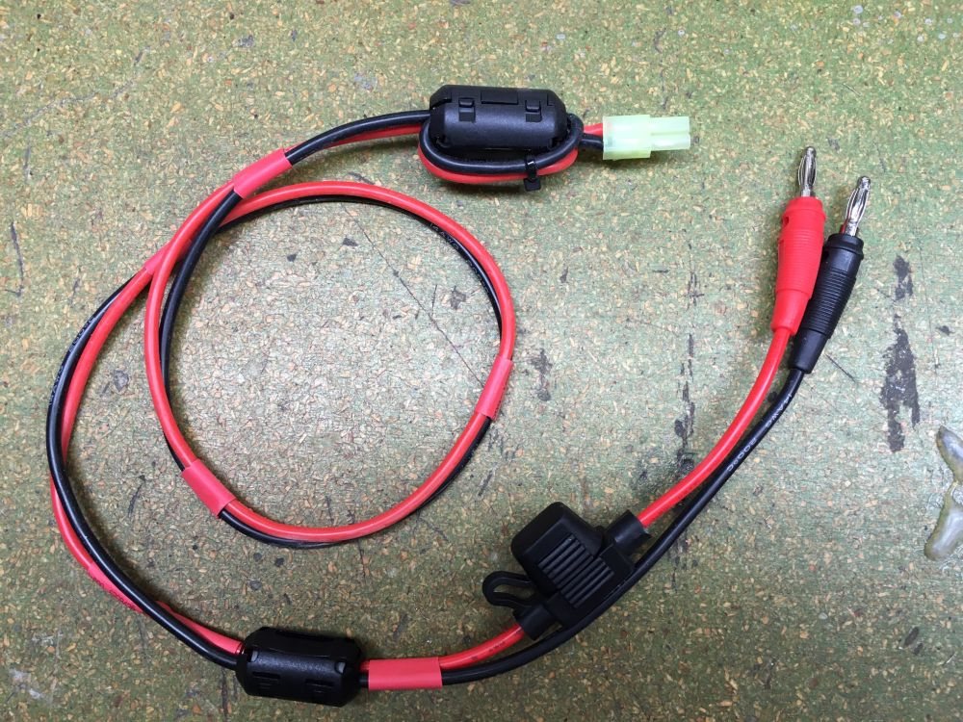

**Microphone Mod**

When using the original G90 microphone, your voice might be too bassy. To solve this problem, open the mic and replace the cpacitor C15 with a 10 nanofarad SMD capacitor and C14 with 2,2 nanofarad (both size 0603). [source](https://xiegug90.groups.io/g/main/profile/@YO2AA)

The following image shows both capacitors (taken from <https://xiegug90.groups.io/g/main/message/1219):>

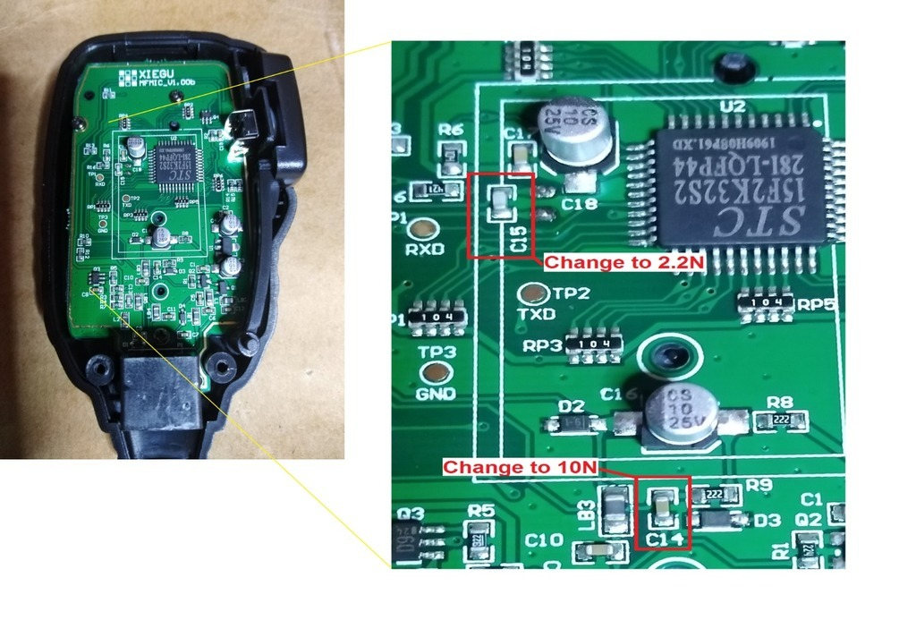

**Ferrite Beads**

In order to prevent radio-frequency interference, all cables should be fitted with ferrite beads:

* Microphone cable
* Power cord
* CAT cable
* Head unit connection cable

**VFO Knob**

Not essential but nice: A larger VFO knob. I bought a black aluminium potentiometer knob for 6mm axis with a size of 32x13mm.

The G90 with a larger VFO knob:

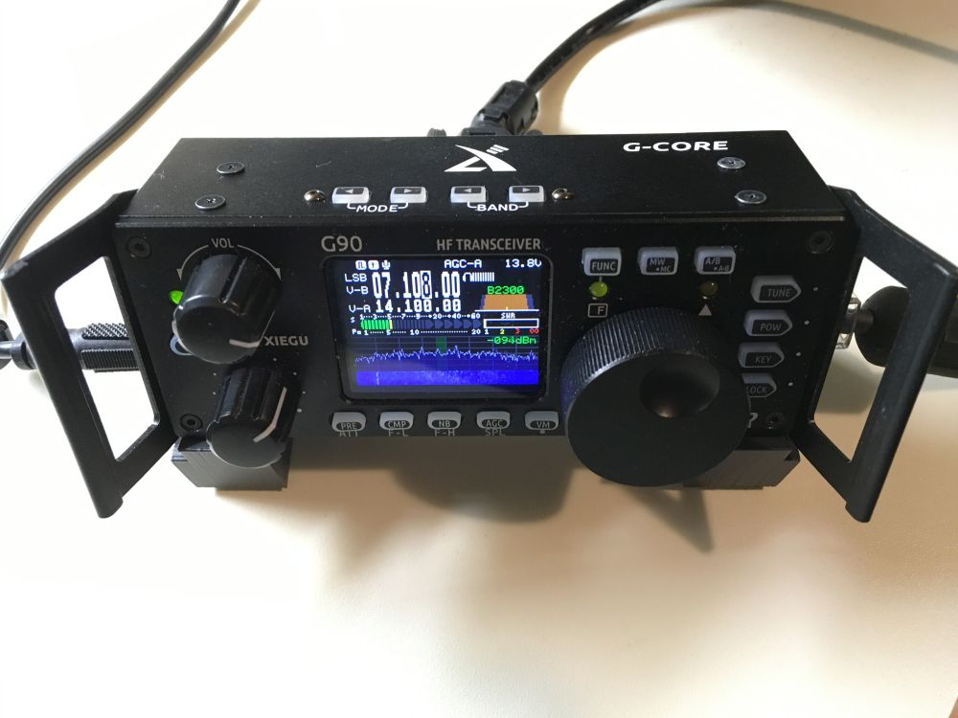

**Head Unit Stand**

I like [this 3D printable design over at thingiverse.com](https://www.thingiverse.com/thing:3741359) for placing the head unit on the table in an ergonomic way.

**Useful other Information**

* Very active and helpful community: [XieguG90](https://xiegug90.groups.io/g/main)
* [G90 Update Instructions](https://xiegug90.groups.io/g/main/files/G90%20Firmware%20Update%20Instructions/G90%20Firmware%20Update%20Instructions.pdf)
* [CI-V Reference](https://xiegug90.groups.io/g/main/files/G90%20CI-V%20REFERENCE.pdf)
* [Cheat Sheet](https://xiegug90.groups.io/g/main/files/XIEGU%20G90%20CHEAT%20SHEET%20v1.73%2012-15-2019.pdf)
* [ini file for OnmiRig](https://xiegug90.groups.io/g/main/files/XieguG90.ini)